**DOCKER - POC**

1. Write a docker file for Java

Launch EC2 instance

SSH into EC2 instance

Install Docker

Add Ubuntu user docker

Install git

Install maven

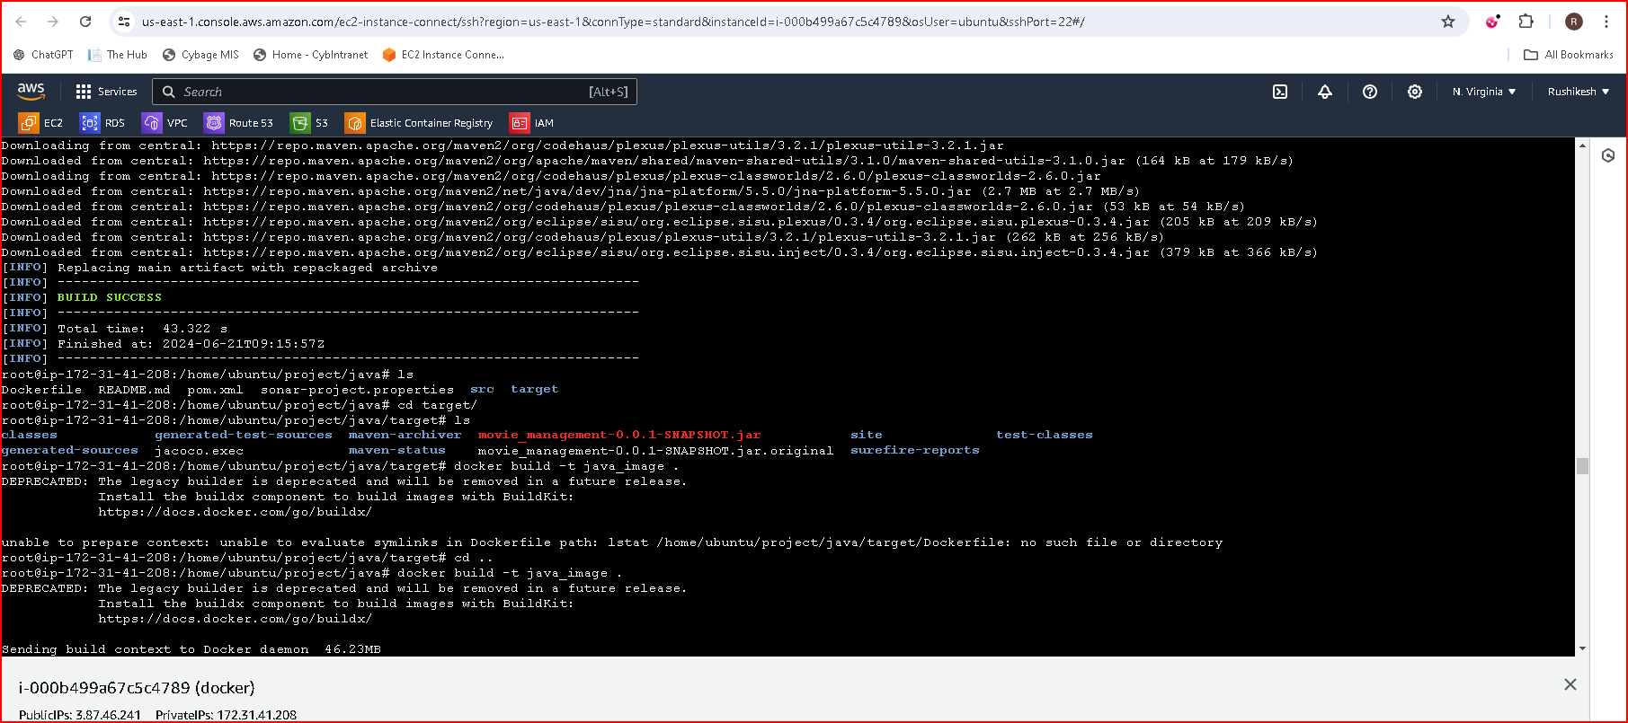

1. **Write a docker file for Python**

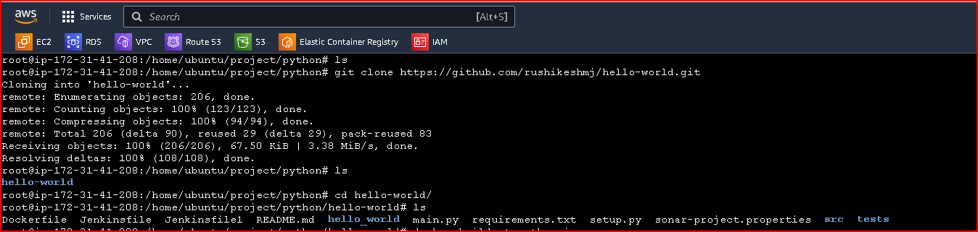

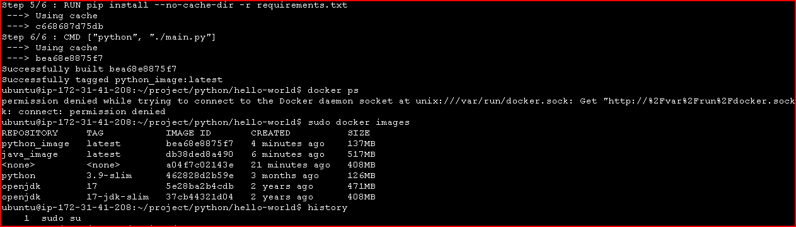

1. **How to override CMD command**

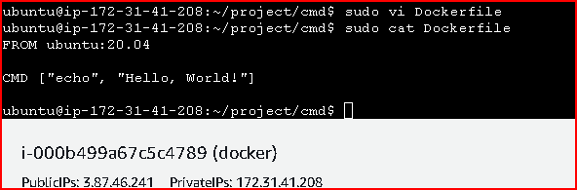

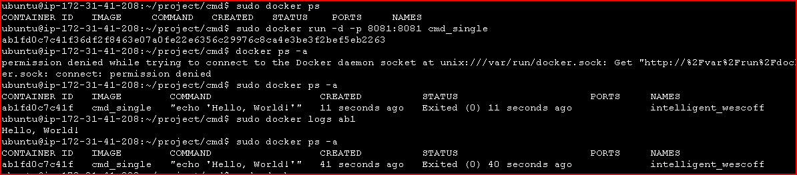

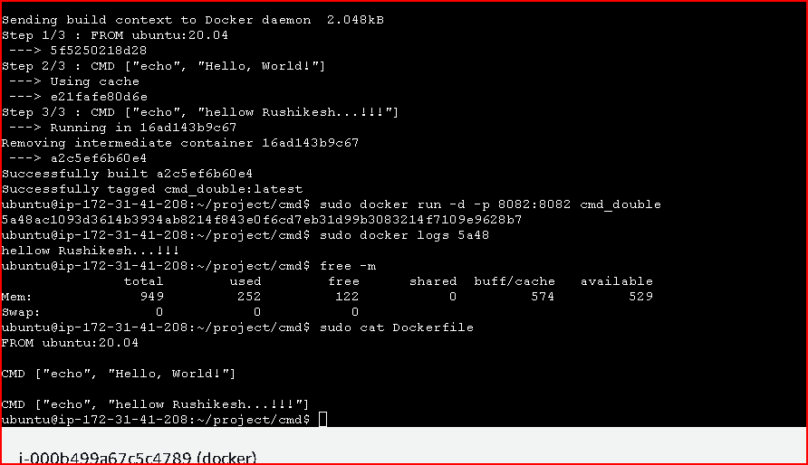

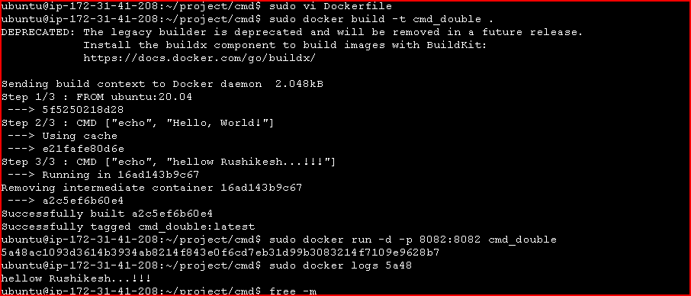

1. **Deploy 3 tier application in docker container expose frontend to internet on same machine**

For a 3-tier application (typically frontend, backend, and database), we can use Docker Compose to orchestrate the deployment

Install docker-compose

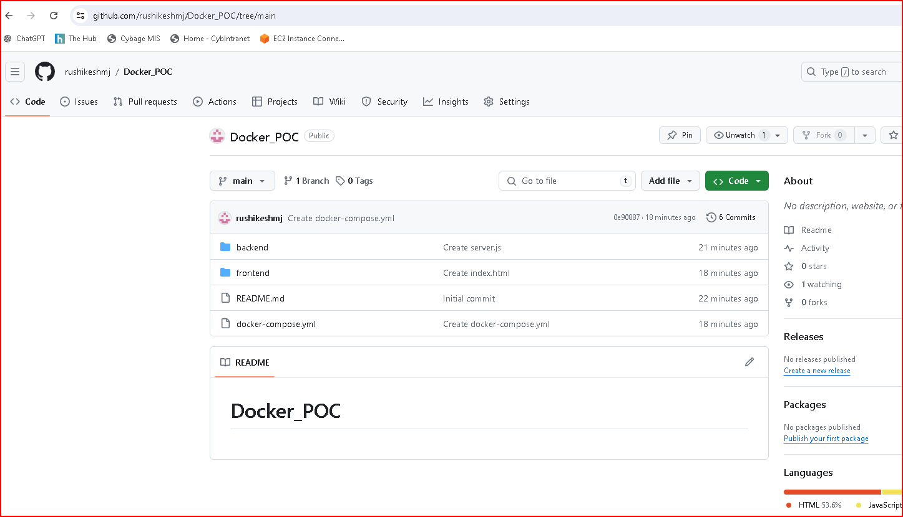

**Clone the project in new directory**

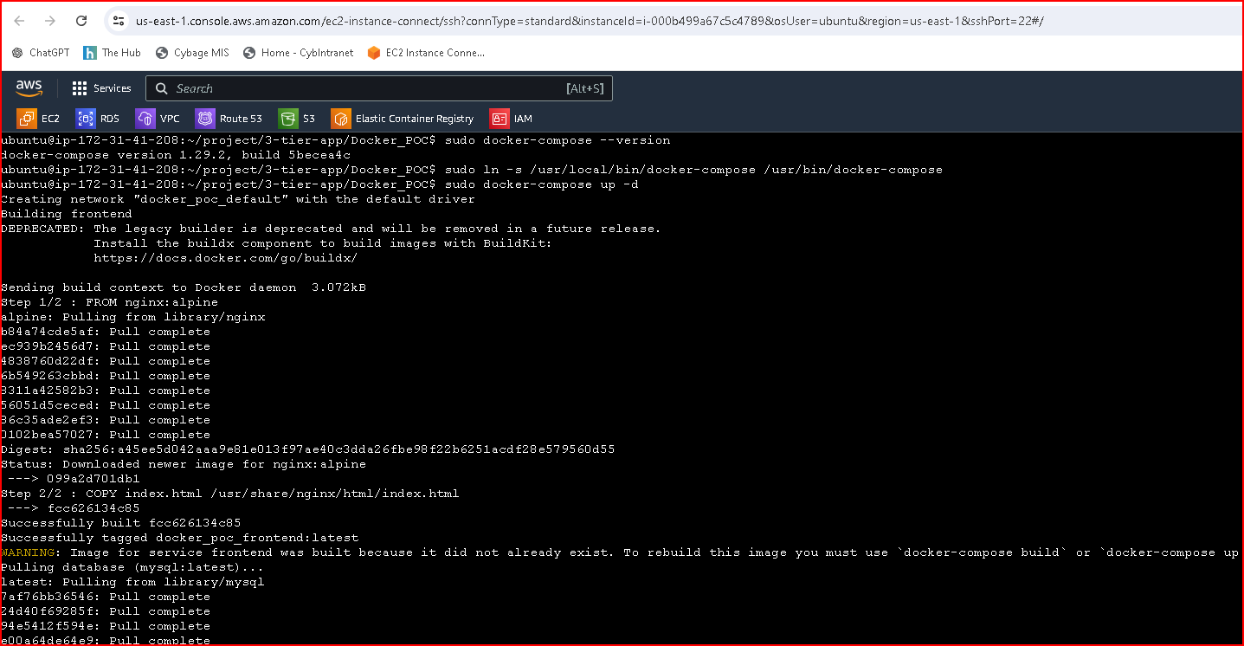

**sudo docker-compose up –d**

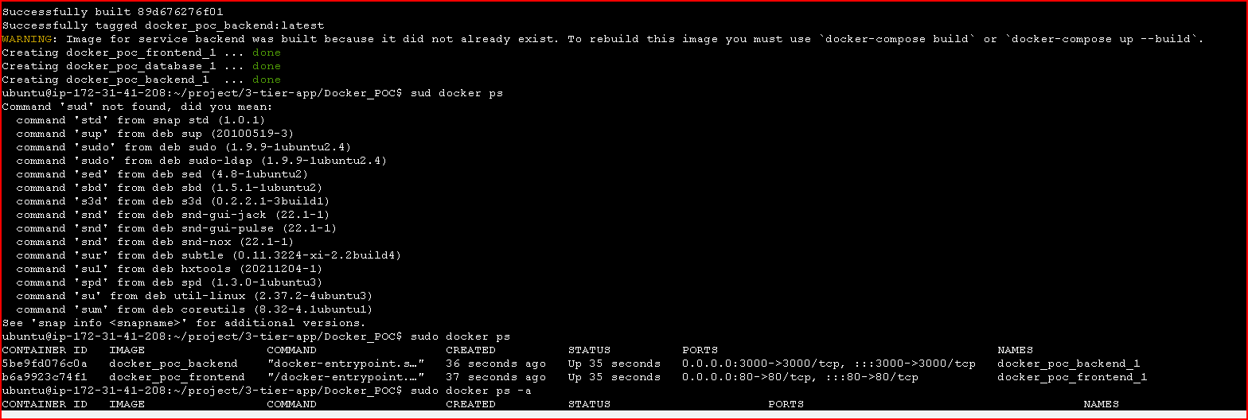

**Frontend**

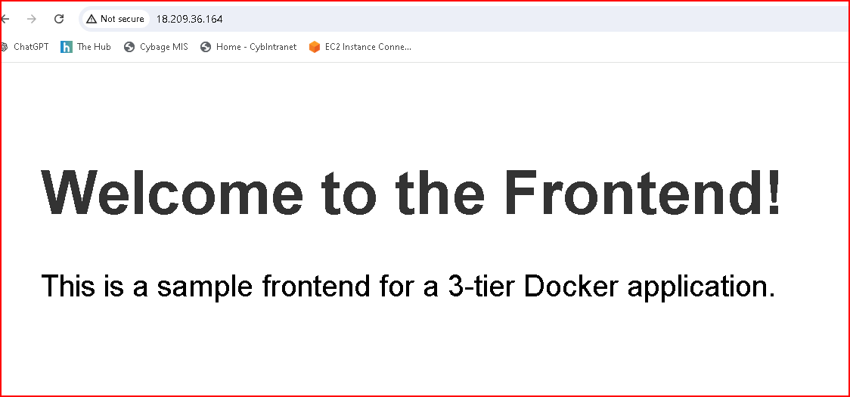

**Backend**

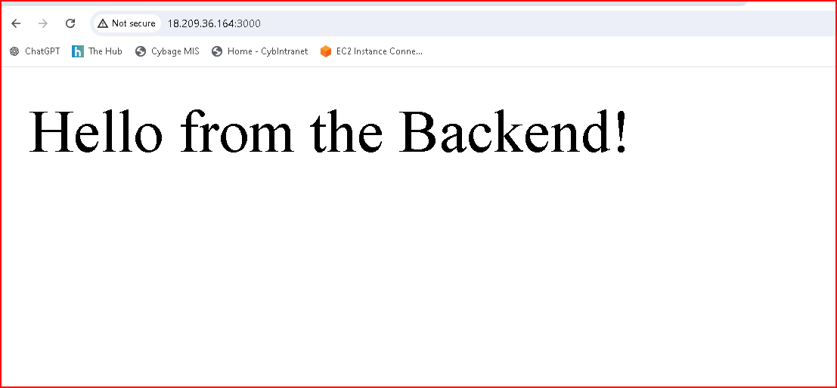

1. **Tag docker image and push it to dockerhub(private repo)**

**Docker tag**

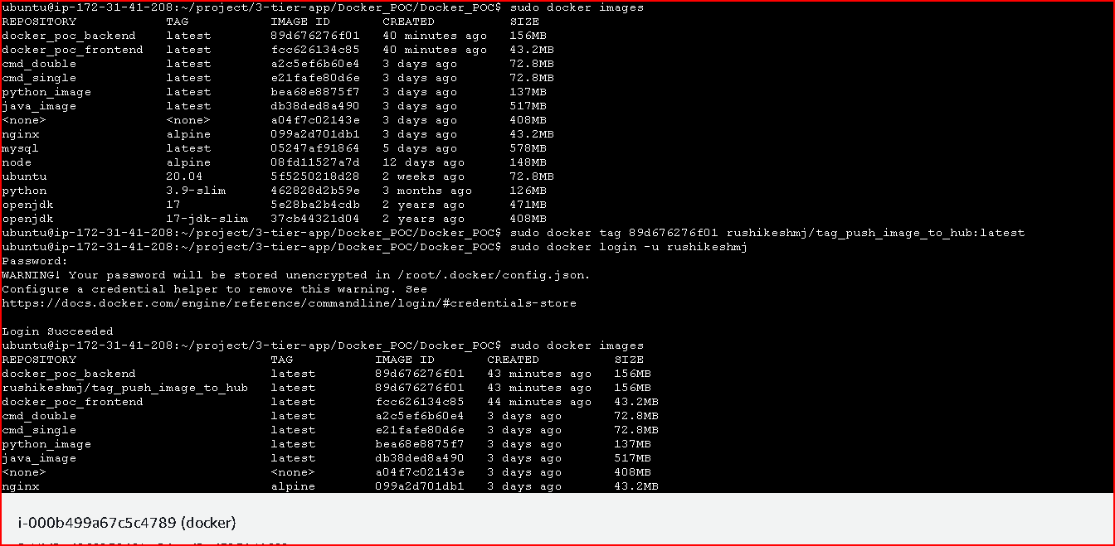

**Docker push**

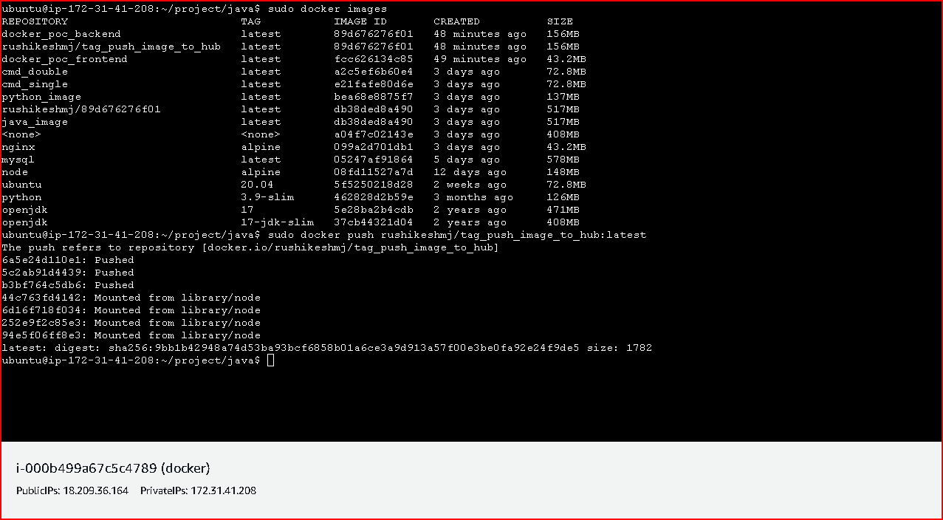

**Pushed into private registry**

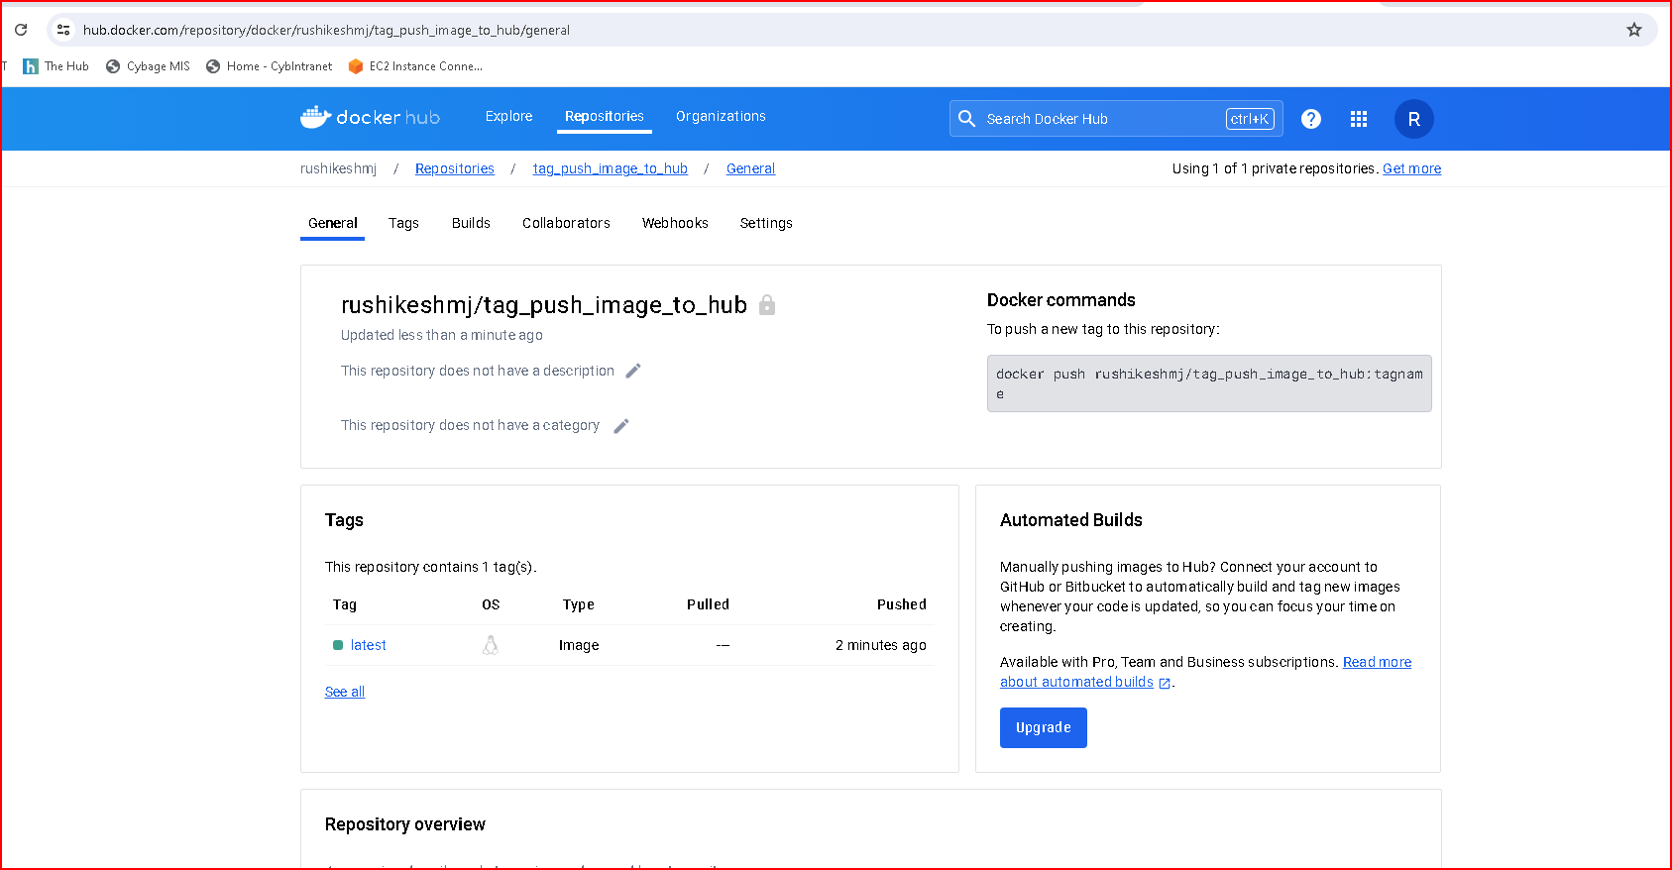

1. **Set env variable using dockerfile as well as command line**

**Set env variable using dockerfile**

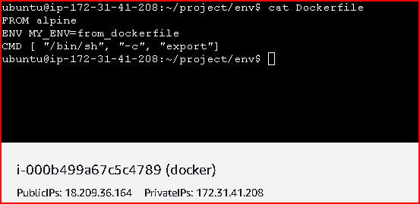

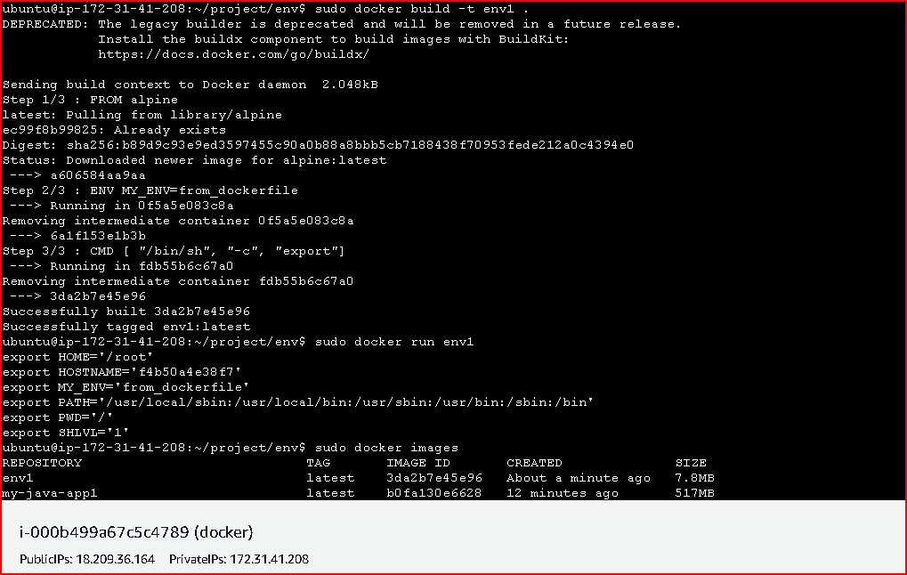

**Set env variable using From CLI**

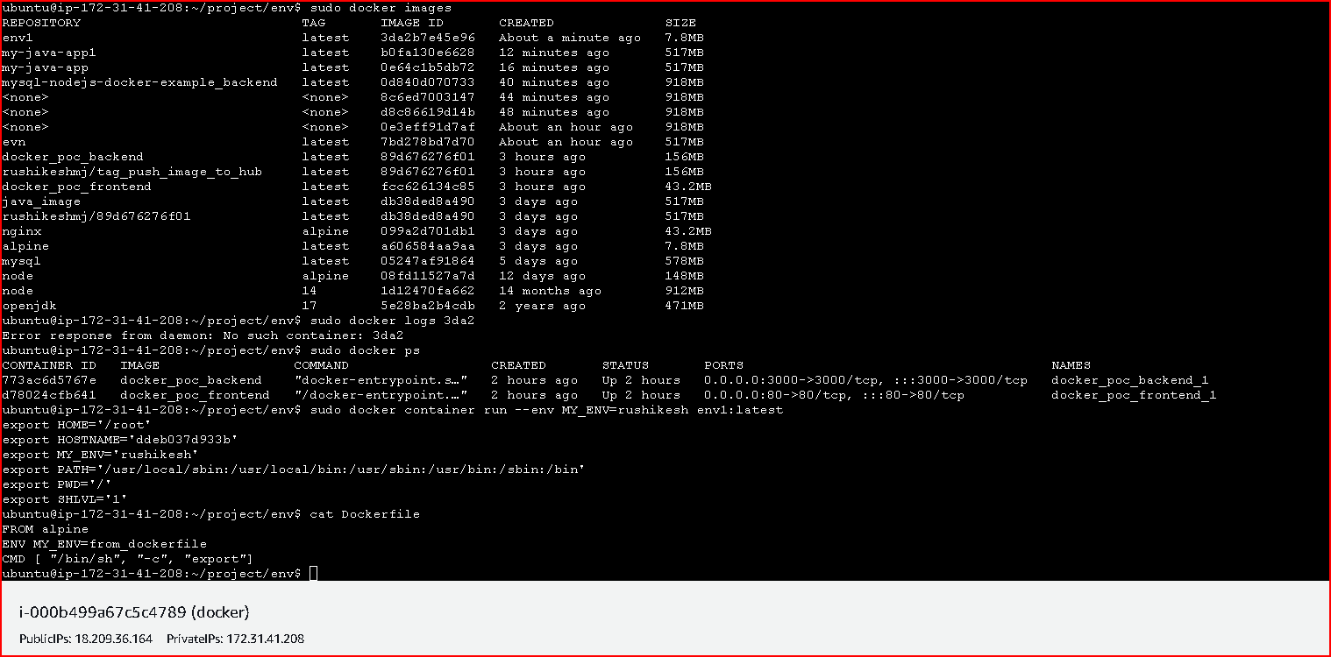

**Use NGNIX as load balancer in 3rd task**

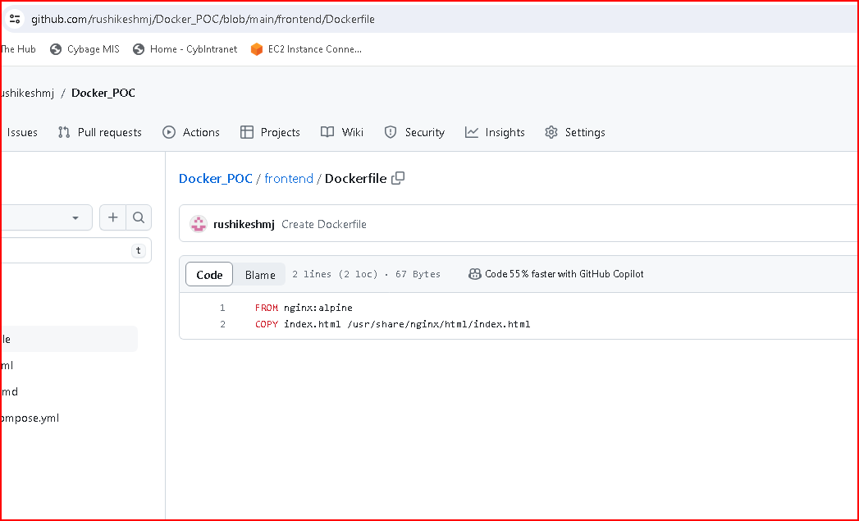

1. **Link mysql container with backend container**

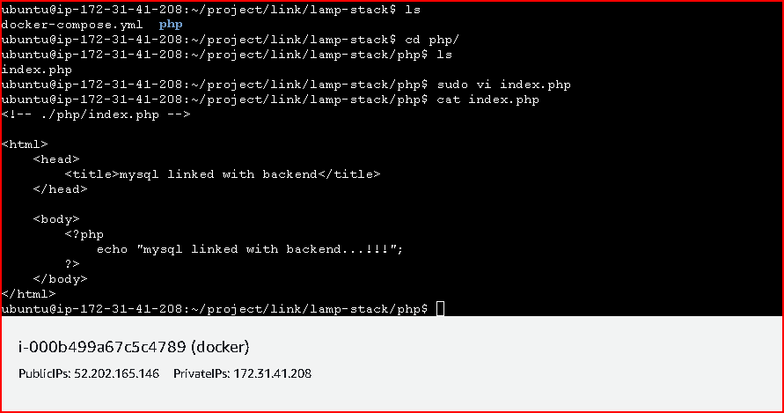

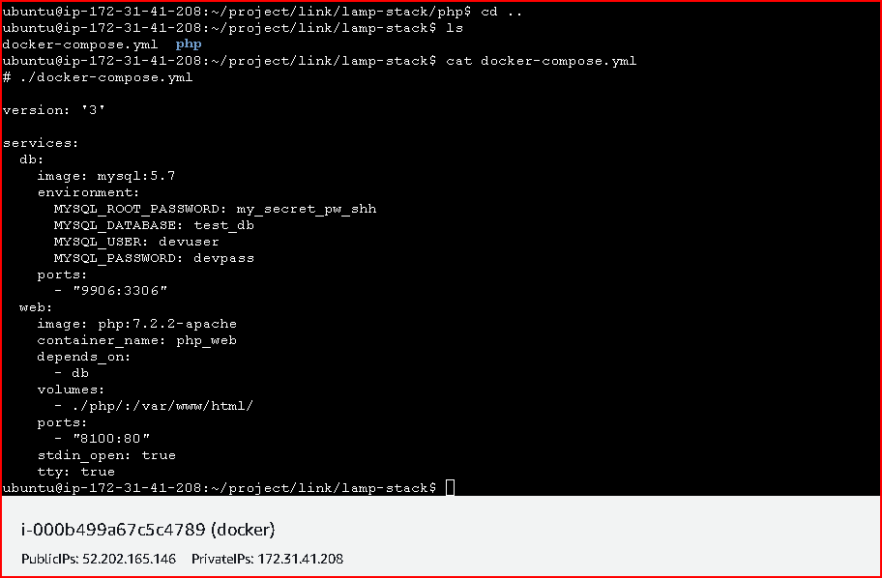

**sudo docker-compose up –d**

